A000-AM,S-Inca-Axe Head-Greenstone-1400 CE

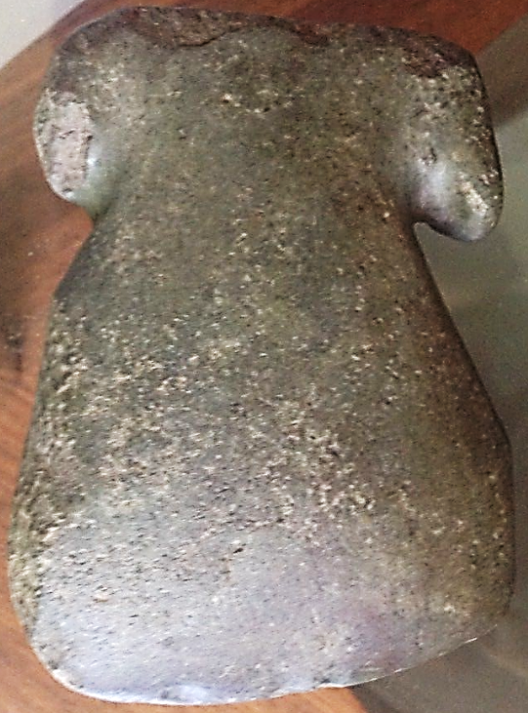

AM,S-Inca-Axe Head-Greenstone-1400 CE

Case No: Projectile Points

Pre-Columbian Inca 'T' shaped axe head, with base slightly concave, nicely executed grooves and sharp blade, carved in dark green stone. Overall fine condition, with chips around one auricle or hafting place.